CMH COLLEGE OF LEGAL STUDIES , CHOWADHI TOP
JAMMU ( 180011 )
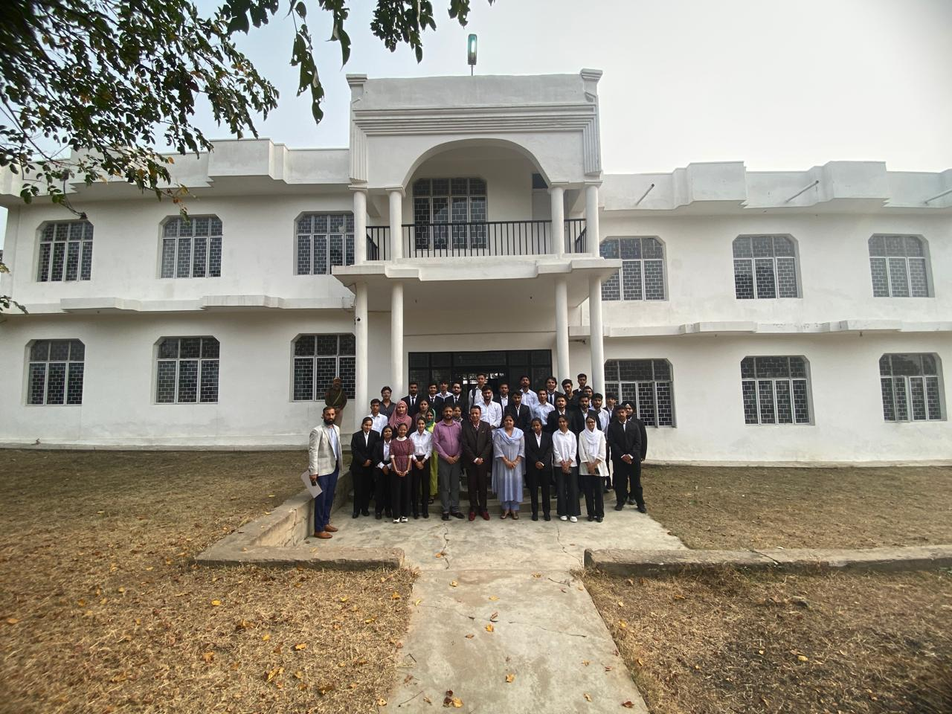

PROSPECTUS
FIRST YEAR B.A. LL.B.
(FIVE YEAR LAW COURSE)
&
FIRST YEAR LL.B.
(THREE YEAR LAW COURSE)
2025- 2026

Contents

- Chairman Desk

- Jammu : The City and University

- Our Roots : The Early Days

- Code of Conduct

- Important Committees

- Admission Process

- Our Faculty

- CMH Campus

- Students Activities

- Undertakings

Chairman Desk

CMH College of Legal Studies is a community of students and staff dedicated to bringing out the best in all of its members. Our aim is to provide the finest opportunities and environment for teaching & learning. We have a distinguished record of academic excellence since the foundation of the college in 2003. The basic principle behind the foundation of CMH College of Legal Studies was to establish a regularized system of imparting legal education. We have endeavoured and achieved this ambition and maintained our standards of excellence. We believe in creating a relaxed and flexible environment to allow students to grow and develop at their own pace.

We offer an education characterized by a mixture of theory and practice and a commitment to public service. This college has always been a firm believer in innovation, both in pedagogy and curriculum. Striving further to harbour individuality of thought and expression and the stimulation to reach the acme of the legal profession, this college organizes a multitude of workshops, conferences and lectures. It has always been the foremost aim of this college to insist on giving students the independence to use the abounding opportunities available and carve out their own niche in college life.

At this college, we give special emphasis on perspectives and insights from other disciplines and encourage an integrated approach to law and an exploration of the legal profession’s socio-economic role and ethical commitments.

Five Reasons to Choose Jammu : The City and University
If you are looking for complete education - look no further. Students from all over the UT and Neighbouring States are flocking to Jammu, as apart from the academic infrastructure, the culture and ethos of the city too seems to have won the hearts of many.
RECOGNITION
The University of Jammu, accredited as 'A++' Grade University by National Assessment & Accreditation Council of India came into existence in 1969 vide Kashmir and Jammu Universities Act 1969 following bifurcation of the erstwhile University of Jammu and Kashmir. The University provides instructions in such branches of learning as it deems fit and makes provision for research and the advancement and dissemination of knowledge. The University stands for spiritual and material elements in life, thirst for knowledge and virtue under the backdrop of holy peaks of Trikuta Hills. Cradled in the lap of mountains at the foothills of auspicious Trikuta, besides the river Tawi at an altitude of 1030 ft. is Jammu. This 'city of temples' has many places that are flocked by people from every nook and corner. Among all these, also comes the famed University of Jammu. A place, where imparting education is not considered just as a mere duty, but as a commitment towards the advancement of the society. A university with a vision and a single-minded mission. To make Jammu university a name to reckon with. A saga that has been continuing from the time of its inception.
ACCESSIBILITY
Jammu is an easily accessible city benefiting from excellent road, rail and air communications. It is well connected to all important cities by direct train services and also has a domestic airport. One can reach the city by road as National Highway 44 runs through Jammu district connecting rest of the UT including the summer capital Srinagar. Daily bus service is available from Jammu to almost all towns of north India. The city has an airport and regular flights run between Jammu and several other cities of the country. All Airlines operate regular daily flights to Jammu connecting different cities. The airport is located 8 kilometres southwest of the city of Jammu, along Ranbir Singh Pura Road. Jammu Tawi is an important rail head of J&K and is connected with important towns and cities of the country by express and super fast trains. Jammu Tawi to Kanyakumari is the second longest rail route of India that touches some of the important cities of the country.
AFFORDABLE LIVING
Jammu has the charm of the small city with facilities. Perfect for students, as almost everything is available at an affordable price – from eating joints to internet cafes. Residential accommodation is easily available and is very economical. The city benefits from an efficient public transport system and general cost of transportation is relatively low. Jammu is one of the most preferred destinations for students in the UT. It is a very safe place to stay in, the low crime rates being a proof of that. The denizens of this city are helpful by nature, and to settle down in this place does not take much effort.
CULTURAL
Jammu: the city of temples, also has a rich cultural heritage. The Basholi paintings and the rich Dogra architectural heritage are famous across the nation. Apart from its geographical context, it is also demographically an amalgamation of varied ethnic and social entities. The diverse religious beliefs co-flourish in the area, and the co-existence of various languages, cultures, and belief systems is astounding. One gets overwhelmed by the sheer diversity and richness of art & architecture, fairs & festivals, rites & rituals, and seers & sagas that thrive amongst the unparalleled cultural cohesion, which is exemplary.
CLIMATE
Jammu district falls in the foothills of the Himalayas. The Shivalik range rises gradually towards the northern part of the district while it merges with the Indo Gangetic plains in the south. Jammu city is situated on the banks of the river Tawi at an elevation of about 367 metres above mean sea level. Jammu district has a sub-tropical extreme climate while it is hot and dry in summer and cold in winter. Nights are generally cooler being in the foothills of the mountains. The day and night temperatures start to fall rapidly from November till mid-February. The temperatures start to rise from March to June. The period of December to February is of winter season while March to third week of June is the summer season, followed by southwest monsoon till September. October and November constitute the post monsoon season.

OUR ROOTS
CMH College of Legal Studies dates back as far as the year 2003, when Jenab Chowdhary Mohmmad Hussain decided to make a new beginning in the direction of a regularized system of imparting legal education. ‘CMH College of Legal Studies’ was therefore started in 2003. It is affiliated to a University of Jammu and Approved by Bar Council of India.
CMH College of Legal Studies is managed by the esteemed Sher-e-Kashmir Secular Educational Trust, led by Chairman Chowdhary Zulfkar Ali, a distinguished figure in law and education. With a background as a Former Cabinet Minister in the J&K Legislative Assembly and a practicing lawyer in the Supreme Court of India, Chairman Ali brings invaluable expertise and vision to the institution. Under his guidance, the college strives to provide quality legal education, fostering a new generation of legal professionals equipped with knowledge, skills, and ethical values. Chairman Ali's leadership reflects his commitment to educational excellence and societal development.

In this contemporary world, the legal system must effectively address the socio-economic and political challenges which society are facing. This necessitates a multi-dimensional legal education system to produce lawyers who contribute to the development of human resources and the ideology of social engineering in a constructive manner. Appreciating these realities, the Bar Council of India, in its Prospective National Planning for Legal Education, envisioned the concept of an Integrated Five-Year Law Course after the 10+2 examination to ensure better professional orientation and greater social relevance for future lawyers.

Aspiring Students in the region with right aptitude for legal training had no option but to go for Integrated Law Course to the other states. CMH College Of Legal Studies sought permission from University of Jammu to initiate Five Year Integrated Law course along with Three Year Professional Law Course.

Code of Conduct
The attention of all students of the college is particularly directed to the following rules.
- It is mandatory for every student to attend at least 75% of total lectures held in each term in the college.
- Every student has to be in class five minutes prior to the commencement of the Class. Any student who is late to the class by more than Five minutes will not be eligible for attendance except under special circumstances.
- No complaint regarding non-marking of attendance in respect of persons those who are not found in the entire class will be entertained.
- Students are expected to attend regularly every working day throughout the academic year. Attending the college examinations, class tests, internal tests and viva-voce are compulsory and absence will not be excused except under special circumstances.
- Any disrespectful conduct towards the professors or other non-teaching staff of the College will attract strict disciplinary actions.
- Loitering the verandas will attract fine.
- Ragging and Eve-teasing are serious offences. Students should not involve in Ragging or Eve-teasing in any form inside or outside the college premises. If any student involves in ragging or eve-teasing, it will result in suspension from the college after due enquiry within 72 hours and appropriate action will be taken under The Jammu and Kashmir Prohibition of Ragging Act 2011 and Bhartiya Nyaya Sanhita 2023.
- It is the responsibility of all the students to protect the property of the College. No part of it shall be broken, damaged, destroyed or defaced and for those found guilty of committing these acts will be suspended and a fine will be levied after enquiry. Wherever it is not possible to detect or find out the erring student or students, depending upon the circumstances a fine will be levied and imposed upon all the students to meet out the cost of replacement or repairs.
- During the class hours, all students must have their mobile phones switched off and inside the campus, students must not use them until there is any academic necessity or emergency.
- Dress Code for Girls will be White shirt, Black Trousers , Black Tie, Black Blazer, Black Shoes or White Salwar Kameez and Black Duppata. Dress Code for Boys will be White shirt, Black Trousers, Black Tie, Black Blazer, and Black Shoes.
Important Committees
Committees working for Students' Welfare:
College Anti-Sexual Harassment Committee
As per the guidelines of UGC, NAAC and Honourable Supreme Court, an Anti-Sexual Harassment Cell has been established in the college to provide a healthy and congenial atmosphere to the female staff members and students of the College.
The committee aims to uphold women’s right to equality, life, and liberty by preventing sexual harassment in the college or workplace. The objectives of the committee are as follows:
- Ensure compliance with the Sexual Harassment of Women at Work Place (Prevention, Prohibition and Redressal) Act, 2013 (POSH Act) to protect women employees and students from sexual harassment.
- Implement a policy for the prevention of sexual harassment in accordance with the directives of the Hon’ble Supreme Court of India.
- Establish a permanent mechanism for preventing and addressing cases of sexual harassment and gender-based violence at the College.
- Develop guidelines for addressing complaints related to sexual harassment of women at the College.
- Promote awareness of gender equity.
In pursuance of Sec 26(1) (g) of the University Grants Commission Act, 1956 read with the University Grants Commission Act (Prevention, prohibition and redressal of sexual harassment of women employees and students in higher educational institutions) Regulations, 2015, the College has set up for this purpose the “Internal Complaints Committee”. Internal Complaint Committee Constitute by following members:

S.No | Name of Faculty | Designation
1. | Maitree Jain | Presiding Officer
2. | Amman Shafqat | Member
3. | Mukesh Sharma | Member , Non- Teaching
4. |  | Member, Student Representative
Anti-Ragging Cell

Ragging is a criminal offense and UGC has framed regulations on curbing the menace of ragging in higher educational institutions in order to prohibit, prevent and eliminate the scourge of ragging. In pursuance to the Judgment of the Hon’ble Supreme Court of India dated 08.05.2009 in Civil Appeal No. 887/2009, in exercise of the powers conferred by clause (g) of sub-section (1) of section 26 of the University Grants Commission Act, 1956, the UGC notified “Regulations on Curbing the Menace of Ragging in Higher Educational Institutions, 2009”.

In pursuance of The Jammu and Kashmir Ragging Act 2011, the College has set up for this purpose the “Anti-Ragging Cell”. Strict Disciplinary Action will be taken against students indulging in any kind of Ragging activity as defined by The Jammu and Kashmir Ragging Act 2011 whether inside or outside the College. Anti-Ragging cell constitute by following members:

S.No | Name of Faculty | Designation
1. | Amman Shafqat | Chairman
2. | Maitree Jain | Member
3. | Abdul Salam | Faculty Representative
4. |  | Senior Student

Online Submission of Anti-Ragging Affidavit
In accordance with the second amendment in UGC Regulations, it is mandatory for every student and parent to submit an online Anti-Ragging Undertaking Affidavit at the beginning of each academic year. This undertaking serves as a formal declaration of their commitment to prevent and discourage ragging in educational institutions.
This online submission ensures that students and parents are actively informed about the regulations, creating a safer and more inclusive campus environment. Institutions are required to facilitate the affidavit process and maintain records of compliance.

Punishment Provisions
Any student or group of students found guilty of ragging on campus or off campus shall be liable to one or more of the following punishments:
• Debarring from appearing in any sessional test/ university examination or withholding results
• Suspension from attending classes and academic privileges
• Withdrawing scholarships and other benefits
• Suspension from the college for a period of one month
• Cancellation of admission
• Suspension/expulsion from the hostel
• Rustication from the institution for periods varying from 1 to 4 semesters or equivalent period
• Expulsion from the institution and consequent debarring from admission to any other institution
• Imprisonment for a term which may extend to two years or with fine which may extend to ten thousand rupees or with both
• Collective punishment - When the students committing or abetting the crime of ragging are not identified, the institution shall resort to collective punishment as a deterrent to ensure community pressure on the potential raggers.

Editorial Board
The Editorial Board Committee of CMH College of Legal Studies serves as the cornerstone for academic and intellectual discourse within the institution. Dedicated to fostering a culture of research, writing, and critical analysis, the committee oversees the publication of scholarly works, including journals, articles, and other legal writings. Comprising a team of esteemed faculty members and talented students, the Editorial Board is committed to upholding the highest standards of academic excellence and promoting impactful contributions to the field of legal studies. Through collaboration and innovation, the committee aims to empower voices that shape the future of legal academia and practice. The Board publishes the college's annual magazine, namely Chinar. Following are the members of Committee:

S.No | Name | Designation
 | Abdul Salam | Editor-In-Chief
 | Sunny Kumar | Associate Editor
 | Sajad Qamar | Section Editor

Sports Committee
The Sports Committee of CMH College of Legal Studies is dedicated to fostering a culture of health, camaraderie, and excellence through sports and physical activities. Recognizing the importance of physical well-being alongside academic pursuits, the committee organizes a variety of sports events, tournaments, and fitness programs to engage students and nurture their talents. With a commitment to inclusivity and teamwork, the committee serves as a platform for students to showcase their skills, build lasting friendships, and develop qualities such as discipline, resilience, and leadership. By encouraging active participation and enthusiasm, the Sports Committee aims to create a vibrant and energetic campus environment. Following are the members of Sports Committee :
S.No | Name | Designation
 | Sunny Kumar | Convener
 | Sajad Qamar | Co - Convener
 | Mukesh Sharma | Member

Admission Process
The Admission for LLB 3 Year ( Professional ) Course and BA LLB 5 Year ( integrated) Law course in the CMH College of Legal Studies shall be made as per norms laid down by the University of Jammu.
Note:-
- The fee shall not be accepted in Instalments , entire amount of prescribed fee shall be paid in full.
- Fee once paid shall not be refunded.
- Annual fee for re-enrollment to next consecutive year should be paid within the Ten days from the dates notified for the commencement of session, after which late fee under rules shall be charged.
- Fee Structure is subject to revision by the University of Jammu from time to time.

Documents required to be submitted along with the Admission Form
- Two photocopies ( duly attested ) of Matric Diploma
- Two photocopies ( duly attested ) of 10 + 2 Mark Sheet
- Two photocopies ( duly attested ) of BA/BSC/B.COM or equivalent examination passed ( in case of LLB 3 Year Course )
- Photocopies of All Semester ( In case of LLB 3 Year Course )
- Original Discharge Certificate and Migration Certificate
- A General Affidavit by all the Candidates.
- Gap Affidavit , if any.
- Eight Recent Passport size coloured photographs.
- A Photocopy of Adhar.
- Each Candidates shall give an undertaking duly signed.
Syllabus
B.A LLB 5 Year Syllabus can be downloaded from official website of University of Jammu. https://www.jammuuniversity.ac.in/lawschool/syllabus
LLB 3 Year Syllabus can be downloaded from Official website of University of Jammu. https://www.jammuuniversity.ac.in/law/syllabus

Our Faculty
Students are instructed and guided by a faculty comprising of professionals proficient in their respective fields of interests. The teachers have an unparalleled commitment to teaching and research. Priority is given to interactive teaching in an amicable study environment, thereby encouraging the students to expand their knowledge beyond the horizon of classroom learning.
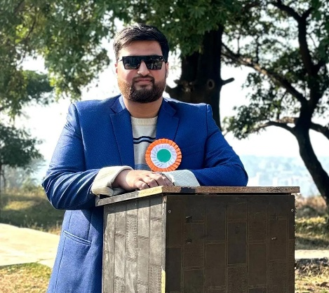

FACULTY PROFILE
Mr. Amman Shafqat Mir Mr. Sajad Qammar
Faculty of Law Faculty of Political Science
B.A.L.LLB 5-Year- B.A from University of Jammu
Law School University of Jammu M.A Political Science from
L.L.M in Constitutional Law Aligarh Muslim University
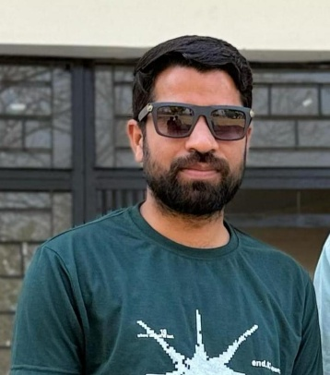
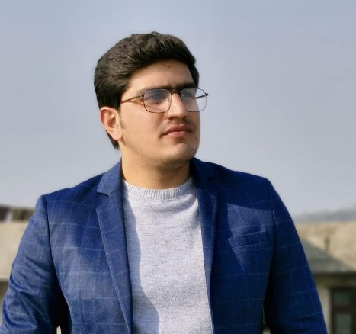
Chandigarh University UGC-NET
Mr. Abdul Salam Mr. Sunny Kumar
Faculty of English Faculty of History
B.A University of Jammu B.A- University of Jammu
M.A English Literature M.A History University of Jammu
University of Jammu P.G Diploma on Culture and Heritage
UGC- NET and JK-SET In English. JK-SET in History

CMH College of Legal Studies Campus
CMH College of Legal Studies, situated at the breathtaking Chowadi Top in Sainik Colony, Jammu was founded in 2003. Perched atop a panoramic hill, the college overlooks the eastern part of the city, providing a serene and tranquil environment that shields students from the hustle and bustle of urban life and its accompanying pollution. This strategic location fosters a conducive atmosphere for academic pursuits, allowing students to focus on their studies and personal growth.
CMH College of Legal Studies boasts an impressive infrastructure designed to foster academic excellence and overall development. Our facilities include:
Well-ventilated classrooms equipped with modern teaching aids
- A moot court room for practical legal training
- A computer lab with high-speed internet connectivity
- Separate common rooms for boys and girls
- A comprehensive library with a vast collection of books and resources
- A college-run canteen offering healthy and hygienic food options
Recreational Facilities
We also offer a range of recreational activities to promote physical and mental well-being, including:
- Outdoor games: badminton, cricket
- Indoor games: table tennis, carrom, chess
Our aim is to provide a holistic environment that supports academic growth, physical fitness, and social interaction.
The CMH College of Legal Studies library is a treasure trove of knowledge, boasting an impressive collection of over 1,800 books covering various aspects of law and related disciplines. Our library's resources are carefully curated to support the academic needs of our students. In addition to our physical book collection, our students also have access to digital subscriptions, providing them with:
- Online access to academic journals, e-books, and databases
- Up-to-date information on legal developments and research
- Remote access to resources, facilitating flexible learning.
Students Activities
To strike a healthy balance between academic and non academic activities, the College emphasizes on the participation of each student in all the extra and cocurricular activities held, by encouraging them to organize and take part in various enriching activities.
Debate Club
Our Debate Club fosters strong arguing skills through various competitions, including debating, elocution, and declamation events, empowering students to articulate their thoughts effectively.
Cultural Club
The Cultural Club in college plays a vital role in enriching campus life. It organizes cultural events, festivals, and activities that promote creativity, diversity, and inclusivity. By providing a platform for students to showcase their talents in music, dance, art, and other creative pursuits, the club fosters teamwork, leadership, and social skills among its members. The club's activities enhance college life with vibrant cultural experiences, including hosting cultural festivals and events, conducting workshops on music, dance, or art, organizing talent shows or performances, and participating in inter-college cultural competitions. Through these initiatives, the Cultural Club creates a dynamic and inclusive environment that celebrates student creativity and talent.
Moot Court
Mooting is an integral part of our curriculum, allowing students to hone their advocacy skills and prepare for a successful legal career. To foster a 'mooting culture,' we host annual internal Moot Court Competitions, providing students with hands-on experience in legal argumentation and courtroom procedures.

Undertakings
I hereby undertake, if admitted to attend the classes as per the rules of CMH College of Legal Studies.
I hereby submit to the disciplinary jurisdiction of the authorities of the University / and the authorities of the College, and shall observe and abide by the rules made by them.
I understand that if admitted, my admission will be confirmed only on production of the Transfer Certificate / Migration Certificate from previous educational institution.
I undertake to obtain an identity card immediately and carry it with me while in the College Premises and to produce it when demanded by college staff.
I am aware that mobile phones, or similar electronic instruments have to be switched off in classrooms, library and during any activity in the College. If such instruments are used during classes, in the library or during activities, the instruments are liable to be confiscated by the college authorities, or fine may be imposed by the college.
I am aware that smoking cigarettes or taking any addictive substance in College premises is prohibited and if found doing these, I will be liable for disciplinary action.
I am also aware that it is my responsibility to keep College premises clean.
I am aware that the college campus is plastic free.
I promise not to indulge in any ragging activity (As defined by The Jammu and Kashmir Ragging Act 2011 ) inside or outside the College...
I promise not to indulge in cyber crime or post any derogatory comment about the college, teachers or fellow students in social media.

